Template Revision History
Associated Written Standard: GxP Track Delivery, WI11.

Version | Change Ref | Reason for Revision
1.0 | ITMS_CR_0219 | First issue of template
2.0 | CR_0034 | Update of instructional box and unhide instructional text

User Requirements for
My Meetings Twin Agent

Approval
Approval of this document denotes that all signatories understand the related process; authors have conducted a review with interested parties; and approvers agree with the content of this document within their areas of accountability.
AUTHORSHIP
Name and function | Signature | Date
Ana Ocariz  Developer/Author | As per electronic document management system | As per electronic document management system
APPROVAL
Name and Function | Signature | Date
Sumit Kaura  Business Owner | As per electronic document management system | As per electronic document management system
Vinciane Polet  Tech Owner | As per electronic document management system | As per electronic document management system
First LastName  Governance, Risk & Compliance (GRC) | As per electronic document management system | As per electronic document management system
First LastName  Quality Assurance (QA) | As per electronic document management system | As per electronic document management system

TABLE OF CONTENTS
1.0 Purpose 4
2.0 Supported Business Processes 4
2.1 Business Process Flow 4
2.2 Business Process Steps 4
2.3 Business Process Rules 5
2.4 Business Process Data Criticality 5
2.5 Business Process Data Retention 5
3.0 User requirement Standards 5
3.1 Nomenclature: Identification and the Numbering Scheme 5
4.0 Intended Use and User Stories 6
4.1 User Stories 6
5.0 User requirements 6
5.1 Meeting Setup Requirements 7
5.2 KPI Data Collection Requirements 7
5.3 Performance & Business Continuity 7
5.4 Security Requirements 7
5.5 Regulatory Requirements 7
5.6 Data Governance Requirements 7
5.7 Interfaces Requirements 8
6.0 Glossary 8
6.1 Acronyms, Key Terms and Definitions 8
7.0 Appendices 8
8.0 References 8
9.0 DOCUMENT Revision History 8

Purpose
This User Requirements (UR) document defines the business and user requirements for the My Meetings Twin Agent Support Solution, developed using Microsoft Copilot Studio.
The My Meetings Twin Agent supports governance meeting preparation by guiding users through structured workflows for KPI tracking, DIA data capture, and meeting readiness activities.
This document captures user-facing functional requirements only, focusing on how the system supports end users in completing meeting preparation tasks.
Technical implementation details are captured separately within the System / Technical Design documentation.

Supported Business Processes
My Meetings Twin Agent (Copilot Studio) | Governance meeting preparation, KPI tracking, DIA data collection and validation | GxP Support, GDPR
KPI Tracking Module | KPI selection, ownership assignment, KPI monitoring | GxP Support
DIA Data Capture Module | Collection and validation of DIA inputs for governance meetings | GxP Support
Notification & Task Module | Triggering notifications and task assignments to KPI owners | GxP Support

Business Process Flow
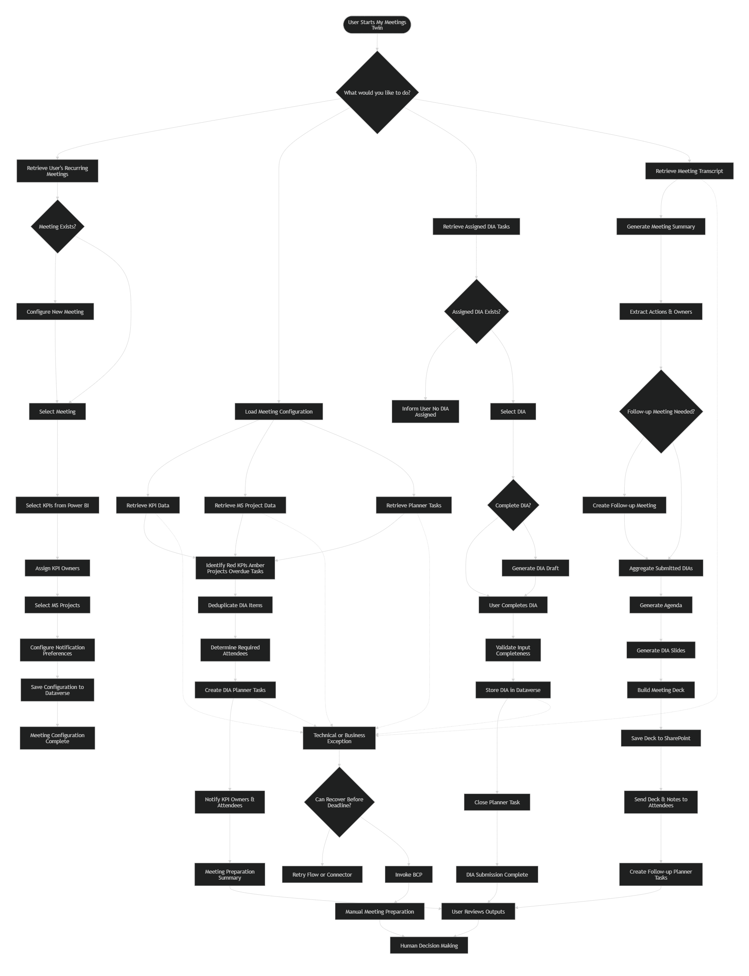

Business Process Steps

BP Ref. | Business Process Step | GxP / SOX Impact
BP-01 | User initiates interaction with the My Meetings Twin Agent | GxP Support
BP-02 | Agent retrieves user preferences and meeting configuration | GxP Support
BP-03 | User selects meeting and relevant KPIs | GxP Support
BP-04 | KPI owners are identified and assigned | GxP Support
BP-05 | Users input DIA data for selected KPIs | GxP Support
BP-06 | Agent validates completeness of inputs | GxP Support
BP-07 | Agent highlights missing inputs or risks (e.g. red KPIs) | GxP Support
BP-08 | Tasks/notifications are triggered for KPI owners | GxP Support
BP-09 | Meeting preparation summary is generated | GxP Support
BP-10 | Agent generates the pre-read pack, timed agenda, and slides | GxP Support
BP-11 | Agent updates required and optional attendees based on DIA submissions and updates the meeting invite | GxP Support
BP-12 | Agent emails the pre-read pack to required and optional attendees | GxP Support
BP-13 | Agent supports post-meeting summary, follow-up task creation, and follow-up meeting creation after the recorded Teams meeting | GxP Support

Business Process Rules

BP Ref. | Business Process Rule | GxP / SOX Impact
BR-01 | Users must complete DIA inputs before meeting preparation is considered complete | GxP Support
BR-02 | Each KPI must have an assigned owner | GxP Support
BR-03 | Missing or incomplete data must be flagged to the user | GxP Support
BR-04 | Users must review outputs before taking decisions | GxP Support
BR-05 | Preparation reminders must follow the business-day timing configured for the recurring meeting | GxP Support
BR-06 | Owners who submit DIA content must become required attendees when the pre-read pack is generated; remaining attendees must be treated as optional | GxP Support
BR-07 | Existing pre-read decks must not be overwritten without user confirmation | GxP Support
BR-08 | Follow-up tasks and meetings must only be created after explicit user confirmation | GxP Support

Business Process Data Criticality

BP Ref. | Data Type / Record | Criticality
BP-02 | User profile data (name, email) | Confidential
BP-03 | Meeting configuration | Proprietary
BP-04 | KPI ownership information | Confidential
BP-05 | DIA input data | Confidential
BP-07 | KPI status indicators | Proprietary
BP-10 | Pre-read agenda, slides, and meeting pack | Proprietary
BP-13 | Meeting transcript, post-meeting notes, follow-up tasks, and follow-up meeting information | Confidential

Business Process Data Retention

Data Type / Record | GRS Category | Description | Retention Period
User preferences | Internal configuration | Meeting setup data | As per system lifecycle
KPI data | Analytical dataset | KPI tracking and reporting | As per Power BI retention policy
DIA inputs | Operational data | Meeting preparation inputs | As per business retention policy
Pre-read packs and generated meeting outputs | Operational data | Meeting preparation and follow-up records | As per business retention policy

User requirement Standards

Nomenclature: Identification and the Numbering Scheme

Range | Description
0100-0199 | System Functions (SF)
0200-0299 | Data Requirements (DA)
0300-0399 | Interface and Integration Requirements
0400-0499 | Feature Level Requirements
0500-0599 | Report and Form Requirements
0X00-0X99 | System Requirements
0X00-0X99 | Regulatory Requirements
0X00-0X99 | Software System Attributes
0X00-0X99 | Hardware Requirements
0X00-0X99 | Safety Requirements
0X00-0X99 | Communications Requirements

Intended Use and User Stories
The My Meetings Twin Agent is intended to assist users in preparing for governance meetings by providing structured guidance for KPI tracking, DIA data input, and meeting readiness.
The agent does not make decisions but supports users by:
- Organising required inputs
- Highlighting risks or missing information
- Facilitating coordination between stakeholders

User Stories

User Story 1 – Meeting Setup
As a meeting organiser, I want to configure meetings and KPIs so that I can prepare structured meeting agendas.

User Story 2 – KPI Data Collection
As a KPI owner, I want to input DIA data so that my KPI is ready for review in the governance meeting.

User Story 3 – Meeting Preparation Review
As a stakeholder, I want to see KPI status and risks so that I can make informed decisions during the meeting.

User Story 4 – Task and Notification Management
As an organiser, I want to notify KPI owners so that all required inputs are completed before the meeting.

User Story 5 – Post-Meeting Summary Generation
As a meeting organiser, I want the agent to read the meeting transcript and draft meeting notes and a summary after the meeting so that I can review and send accurate post-meeting communications.

User Story 6 – Follow-Up Task Creation
As a meeting organiser, I want the agent to identify follow-up actions, show the proposed task owners and titles, and allow me to edit or remove tasks before creation so that only relevant follow-up work is added to Planner.

User Story 7 – Follow-Up Meeting Creation
As a meeting organiser, I want the agent to identify whether a follow-up meeting is needed and create the meeting invite only after my confirmation so that required follow-up discussions are scheduled without removing user control.

User Story 8 – Preparation Reminder and DIA Initiation
As a meeting organiser, I want the agent to send preparation reminders based on the configured business-day timing and help me initiate DIA task creation so that owners are prompted at the right point in the meeting cycle.

User Story 9 – DIA Submission Support
As a DIA owner, I want to see the update I owe, complete it manually, use an agent-generated draft, or mark that I have nothing to contribute so that my submission can be completed efficiently and transparently.

User Story 10 – Pre-Read Pack Generation and Distribution
As a meeting organiser, I want the agent to generate the meeting pack, timed agenda, slides, attendee updates, invite update, and email distribution so that the pre-read is prepared and shared consistently.

User Story 11 – Pre-Read Regeneration
As a meeting organiser, I want the agent to detect when a meeting deck already exists and ask whether to create a new version so that agenda changes can be reflected without overwriting previous material unintentionally.

User requirements
Meeting Setup Requirements

Meeting Setup Requirements
UR ID | Requirement Statement
UR-0101 | The system shall allow users to configure meetings and associated KPIs
UR-0102 | The system shall allow users to update meeting configuration preferences
UR-0103 | The system shall retrieve previously configured meetings
UR-0104 | The system shall allow users to select the recurring meeting they organise.
UR-0105 | The system shall allow users to choose the Planner plan used for DIA and follow-up tasks.
UR-0106 | The system shall allow users to set the meeting Tier level, Tier ID, and Purpose used in the agenda.
UR-0107 | The system shall allow users to select KPIs and MS Projects to track, assign owners, or skip KPI and MS Project selection.
UR-0108 | The system shall allow users to configure how many business days before the meeting preparation reminders start and reuse the saved setup each cycle.

KPI Data Collection Requirements
UR ID | Requirement Statement
UR-0201 | The system shall allow users to input DIA data for KPIs
UR-0202 | The system shall validate completeness of DIA inputs
UR-0203 | The system shall highlight missing or incomplete DIA data
UR-0204 | The system shall allow users to enter the date range used to identify off-target KPIs and overdue items.
UR-0205 | The system shall return flagged red KPIs, overdue items before DIA task creation.
UR-0206 | The system shall create DIA tasks for red KPI owners and meeting attendees without flagged KPIs only after organiser confirmation.
UR-0207 | The system shall allow DIA owners to complete submissions manually, use an agent-generated draft, mark nothing to contribute, and submit their response.
UR-0208 | The system shall show submitted and not-submitted DIA acknowledgement statuses for the selected meeting.

Performance & Business Continuity
UR ID | Requirement Statement
UR-0301 | The system shall respond to user inputs within acceptable Copilot response times
UR-0302 | The system shall remain available during standard business hours. Note: the automated notification processing (PA_SendDIANotificationToOrganizer) runs continuously on an hourly schedule, independent of business hours.

5.3A Pre-Read and Meeting Pack Requirements
UR ID | Requirement Statement
UR-0351 | The system shall gather submitted DIA inputs and generate a timed agenda and slide deck for the meeting pack.
UR-0352 | The system shall save the generated meeting pack as the meeting pre-read.
UR-0353 | The system shall recalculate required and optional attendees when the meeting pack is generated.
UR-0354 | The system shall update the meeting invite attendee lists based on the recalculated required and optional attendees.
UR-0355 | The system shall email the generated pre-read pack to required attendees on To and optional attendees on Cc.
UR-0356 | The system shall detect an existing meeting slide deck and request user confirmation before creating a new deck version.

Security Requirements
UR ID | Requirement Statement
UR-0401 | The system shall authenticate users via Microsoft Entra ID
UR-0402 | The system shall restrict data access based on user permissions
UR-0403 | The system shall ensure users can only access authorised meeting data

Regulatory Requirements
UR ID | Requirement Statement
UR-0501 | The system shall allow retrieval of records in a human-readable format
UR-0502 | The system shall allow export of relevant data for audit purposes

Data Governance Requirements
UR ID | Requirement Statement
UR-0601 | The system shall maintain ownership of KPI and DIA data
UR-0602 | The system shall ensure data is processed in accordance with organisational policies
UR-0603 | The system shall apply appropriate data classification controls

Post-Meeting Requirements
UR ID | Requirement Statement
UR-0801 | The system shall allow users to select a completed meeting from the Post-Meeting flow.
UR-0802 | The system shall read the available Teams meeting transcript and draft meeting notes and a summary for user review.
UR-0803 | The system shall present drafted notes and summary to the user for review before they are sent or used as meeting output.
UR-0804 | The system shall identify follow-up actions and proposed owners from the post-meeting content.
UR-0805 | The system shall allow users to review, update task titles, or remove proposed follow-up tasks before task creation.
UR-0806 | The system shall create approved follow-up tasks in Planner only after user confirmation.
UR-0807 | The system shall identify when a follow-up meeting is required and present the proposed meeting to the user for confirmation.
UR-0808 | The system shall create and send a follow-up meeting invite only after explicit user confirmation.

Interfaces Requirements
UR ID | Requirement Statement
UR-0701 | The system shall integrate with Microsoft Graph (Note: actual connectors also include Planner, Microsoft Teams, Office 365 Outlook, and SharePoint Online) for user and meeting data
UR-0702 | The system shall integrate with Dataverse for configuration storage
UR-0703 | The system shall integrate with Power BI for KPI data retrieval

Glossary

Acronyms, Key Terms and Definitions
Term / Acronym | Definition
DIA | Decision / Input / Awareness
KPI | Key Performance Indicator
MS Project | Microsoft Project item tracked as part of meeting preparation and DIA input generation
Pre-read | Generated meeting pack containing DIA inputs, timed agenda, and slides shared before the meeting
Planner | Microsoft task management application used for DIA tasks and post-meeting follow-up tasks
Copilot Studio | Microsoft platform used to build the conversational agent
My Meetings Twin Agent | Conversational assistant supporting meeting preparation

Appendices

Appendix ID | Appendix Name or Title
<Appendix ID> | <Title of Appendix A>

References

VQD ID | DTMS ID | Document Title
 | <Doc Number> | <<Product Overview document>>

DOCUMENT Revision History
Version | Revision Details
Draft update | Updated user stories, business process coverage, requirements, data criticality, data retention, glossary, and post-meeting coverage based on the uploaded monthly meeting-prep calendar.

